Sudan

## Respect for rule of law (ROL) data

The data set shows the data on the respect of the rule of law for the country.

## # A tibble: 20 x 5  
## country iso3c date ruleOfLaw ruleOfLawCategory4   
## <chr> <chr> <dbl> <dbl> <chr>   
## 1 Sudan SDN 1996 -1.71 ROL highly disrespected  
## 2 Sudan SDN 1998 -1.69 ROL highly disrespected  
## 3 Sudan SDN 2000 -1.60 ROL highly disrespected  
## 4 Sudan SDN 2002 -1.36 ROL highly disrespected  
## 5 Sudan SDN 2003 -1.64 ROL highly disrespected  
## 6 Sudan SDN 2004 -1.54 ROL highly disrespected  
## 7 Sudan SDN 2005 -1.63 ROL highly disrespected  
## 8 Sudan SDN 2006 -1.36 ROL highly disrespected  
## 9 Sudan SDN 2007 -1.40 ROL highly disrespected  
## 10 Sudan SDN 2008 -1.42 ROL highly disrespected  
## 11 Sudan SDN 2009 -1.24 ROL highly disrespected  
## 12 Sudan SDN 2010 -1.31 ROL highly disrespected  
## 13 Sudan SDN 2011 -1.28 ROL highly disrespected  
## 14 Sudan SDN 2011 -1.28 ROL highly disrespected  
## 15 Sudan SDN 2012 -1.23 ROL highly disrespected  
## 16 Sudan SDN 2013 -1.27 ROL highly disrespected  
## 17 Sudan SDN 2014 -1.17 ROL highly disrespected  
## 18 Sudan SDN 2015 -1.21 ROL highly disrespected  
## 19 Sudan SDN 2016 -1.26 ROL highly disrespected  
## 20 Sudan SDN 2017 -1.11 ROL highly disrespected

## Respect for rule of law (ROL) trend

The plot shows the trend of the respect for the rule of law for the country.

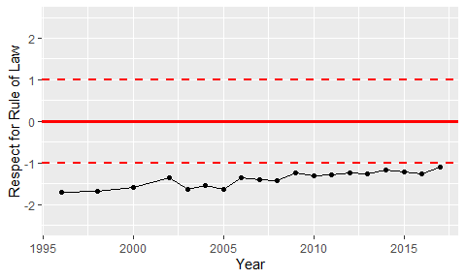

Trend of the Respect for the Rule of Law